Lab 1

Creating instances and making ssh connection using putty.

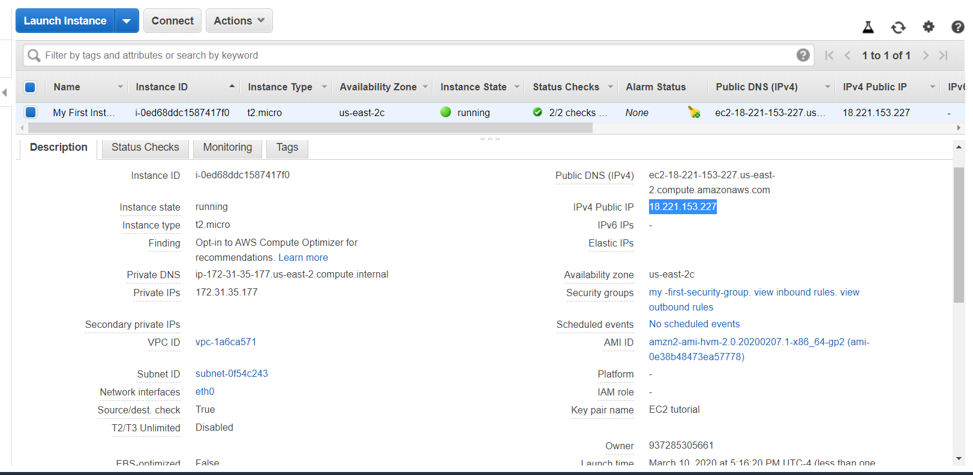

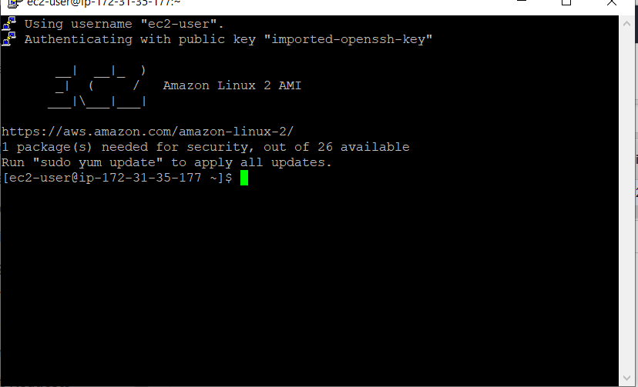

Changing it to elastic IP we got:

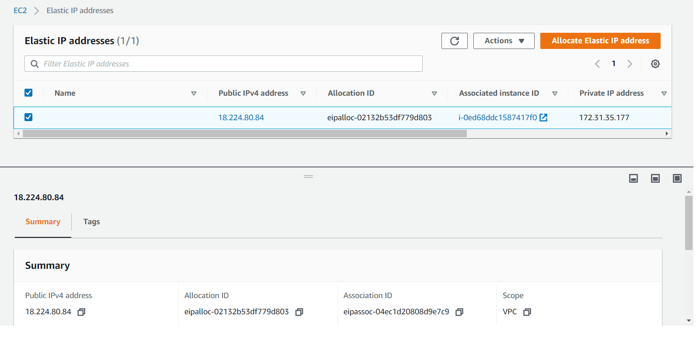

Now associating this IP in our current running instance.

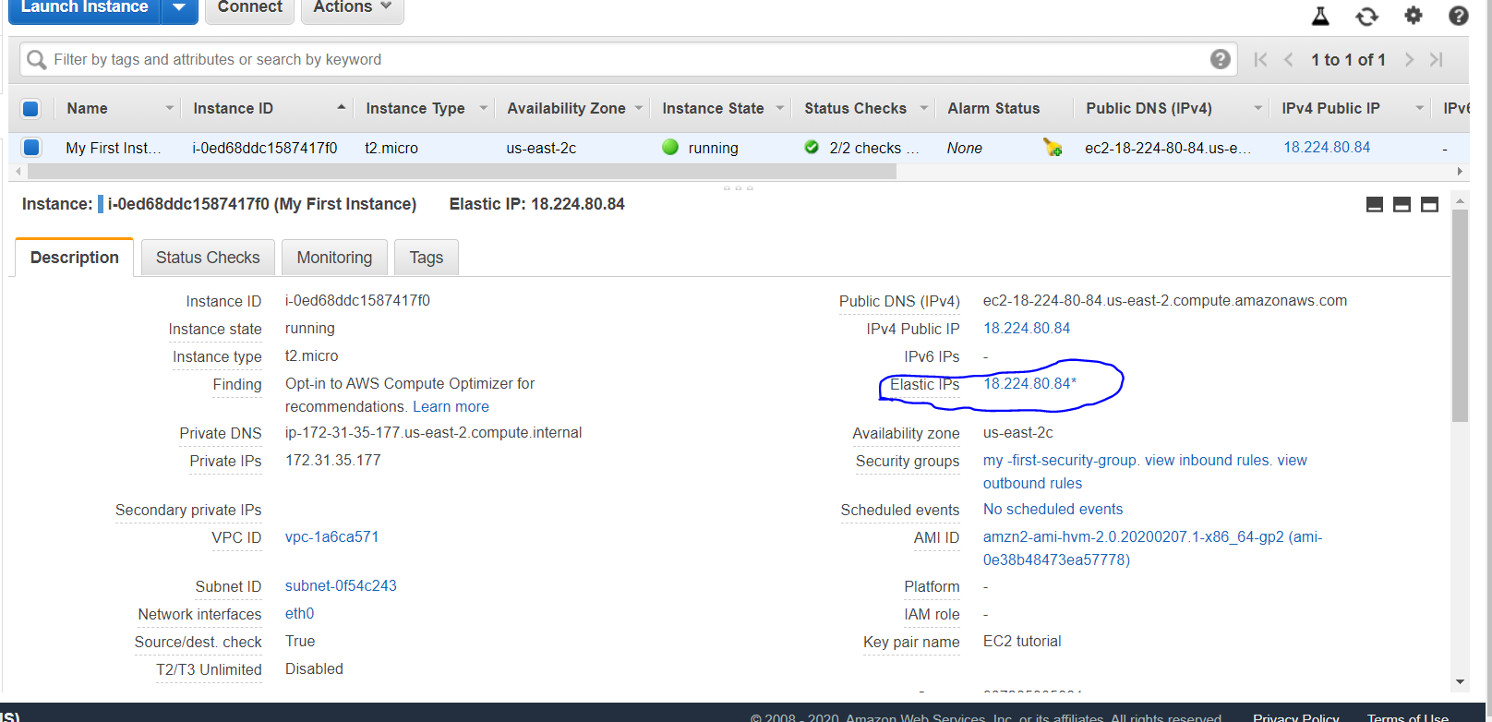

Making SSH connection with elastic IP.

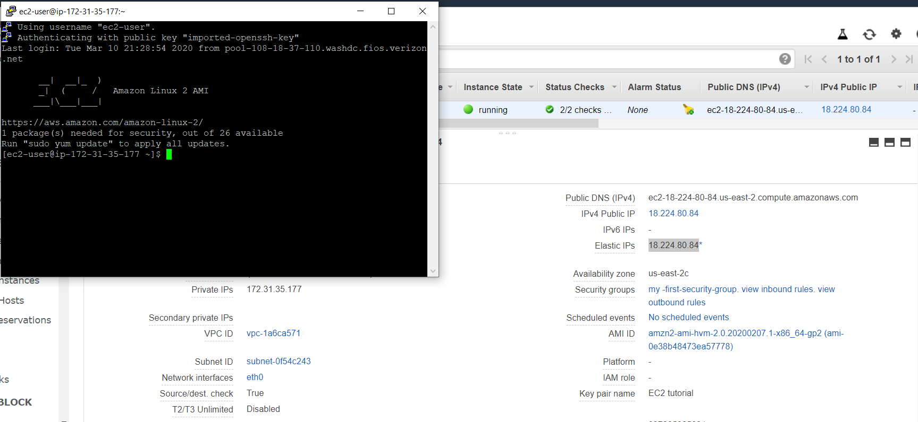

Disassociating elastic IP

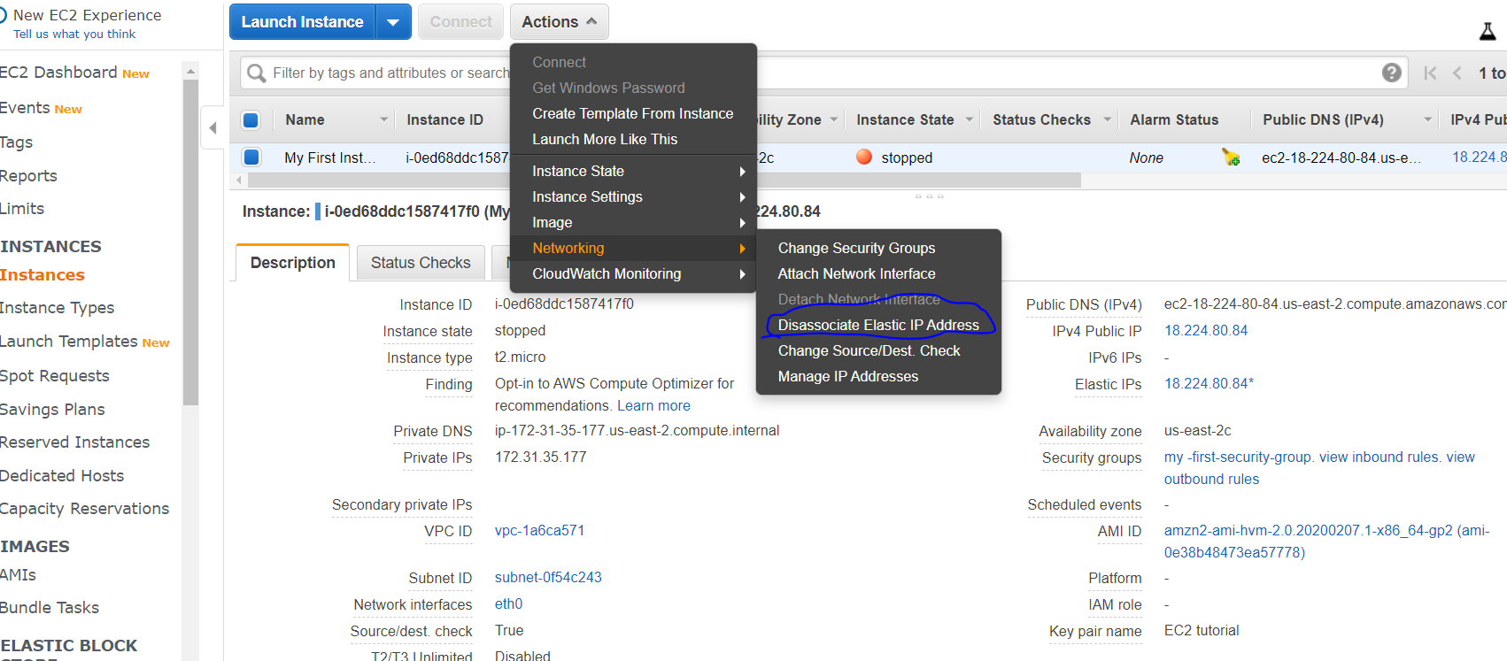

Now installing Apache web server

For that firstly “sudo su” to get the privilege of root.

2. yum update -y : this will update the machine itself.

3. yum install httpd.x86_64

Then the following commands are used.

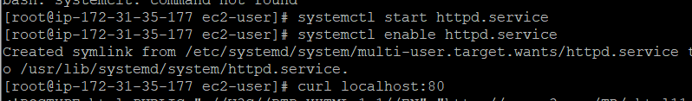

After this when you go and browse public IP on browser, it will time out because we have not done setting on security role. So

Editing security group and allowing http protocol to pass in inbound rule.

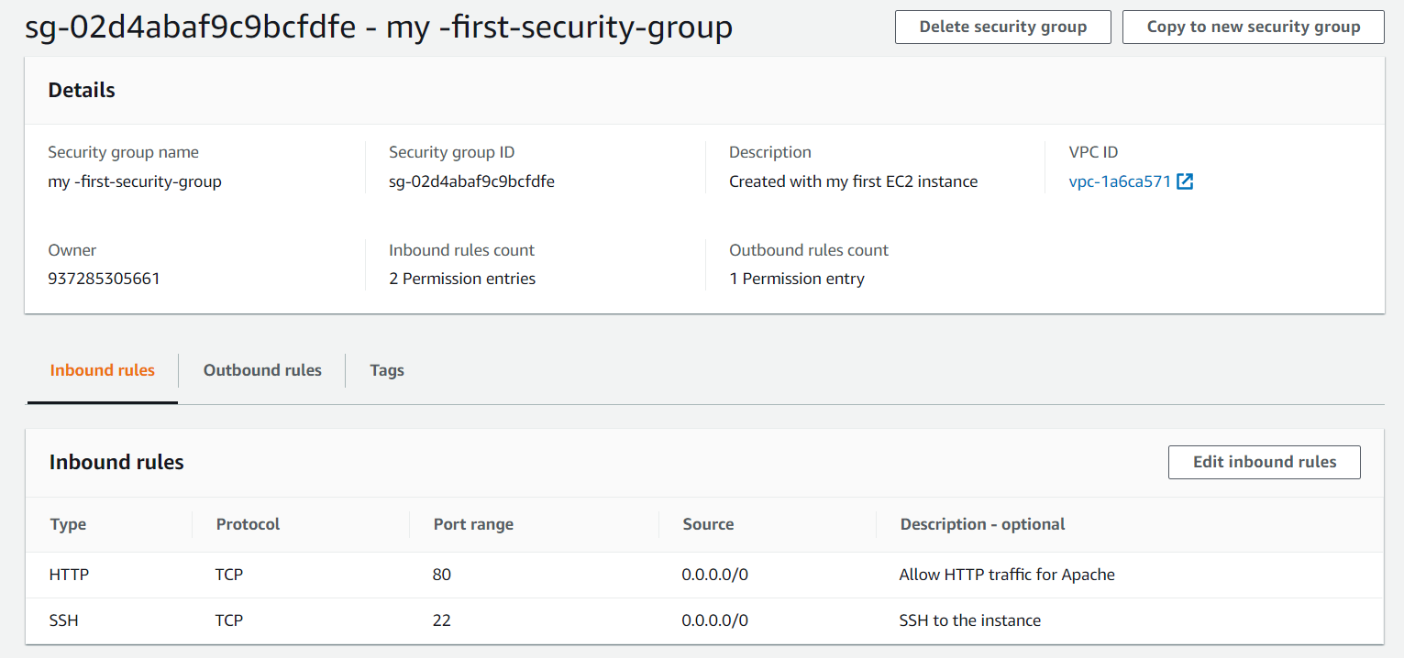

After configuring security role we got

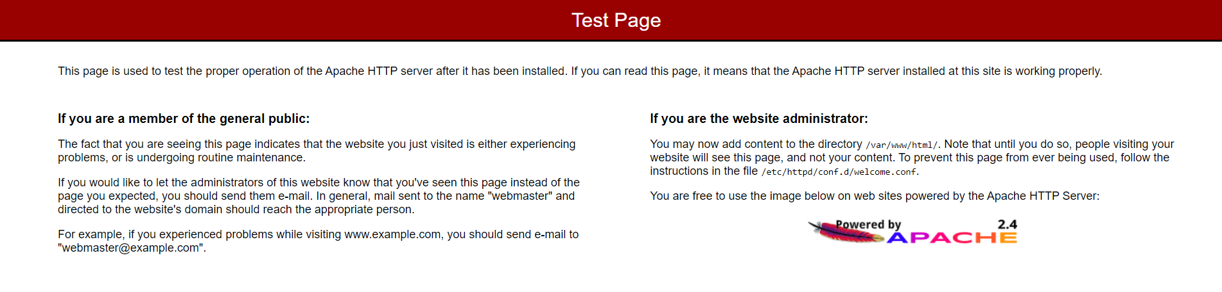



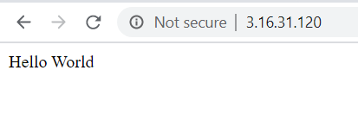

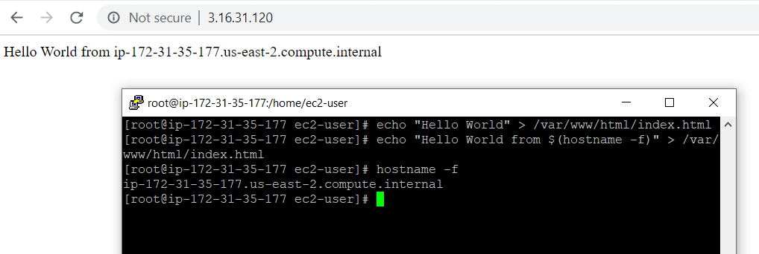

Lab 2 EC2 USER DATA

EC2 user data automate boot tasks. It includes installing updates, software, downloading comman files from the internet.

The script used is

#!bin/bash

#install httpd (Linux 2 version)

yum update -y

yum install -y httpd.x86_64

systemctl start httpd.service

sysetemctl enable httpd.service

echo "Hello World from $(hostname -f)" > /var/www/html/index.html

After creating second instance and using bash shell script in user data, we got

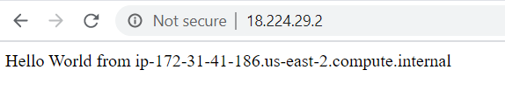

Checking what we have on .html file. We get

